Kiel Russell

Lab 4

Task 1:

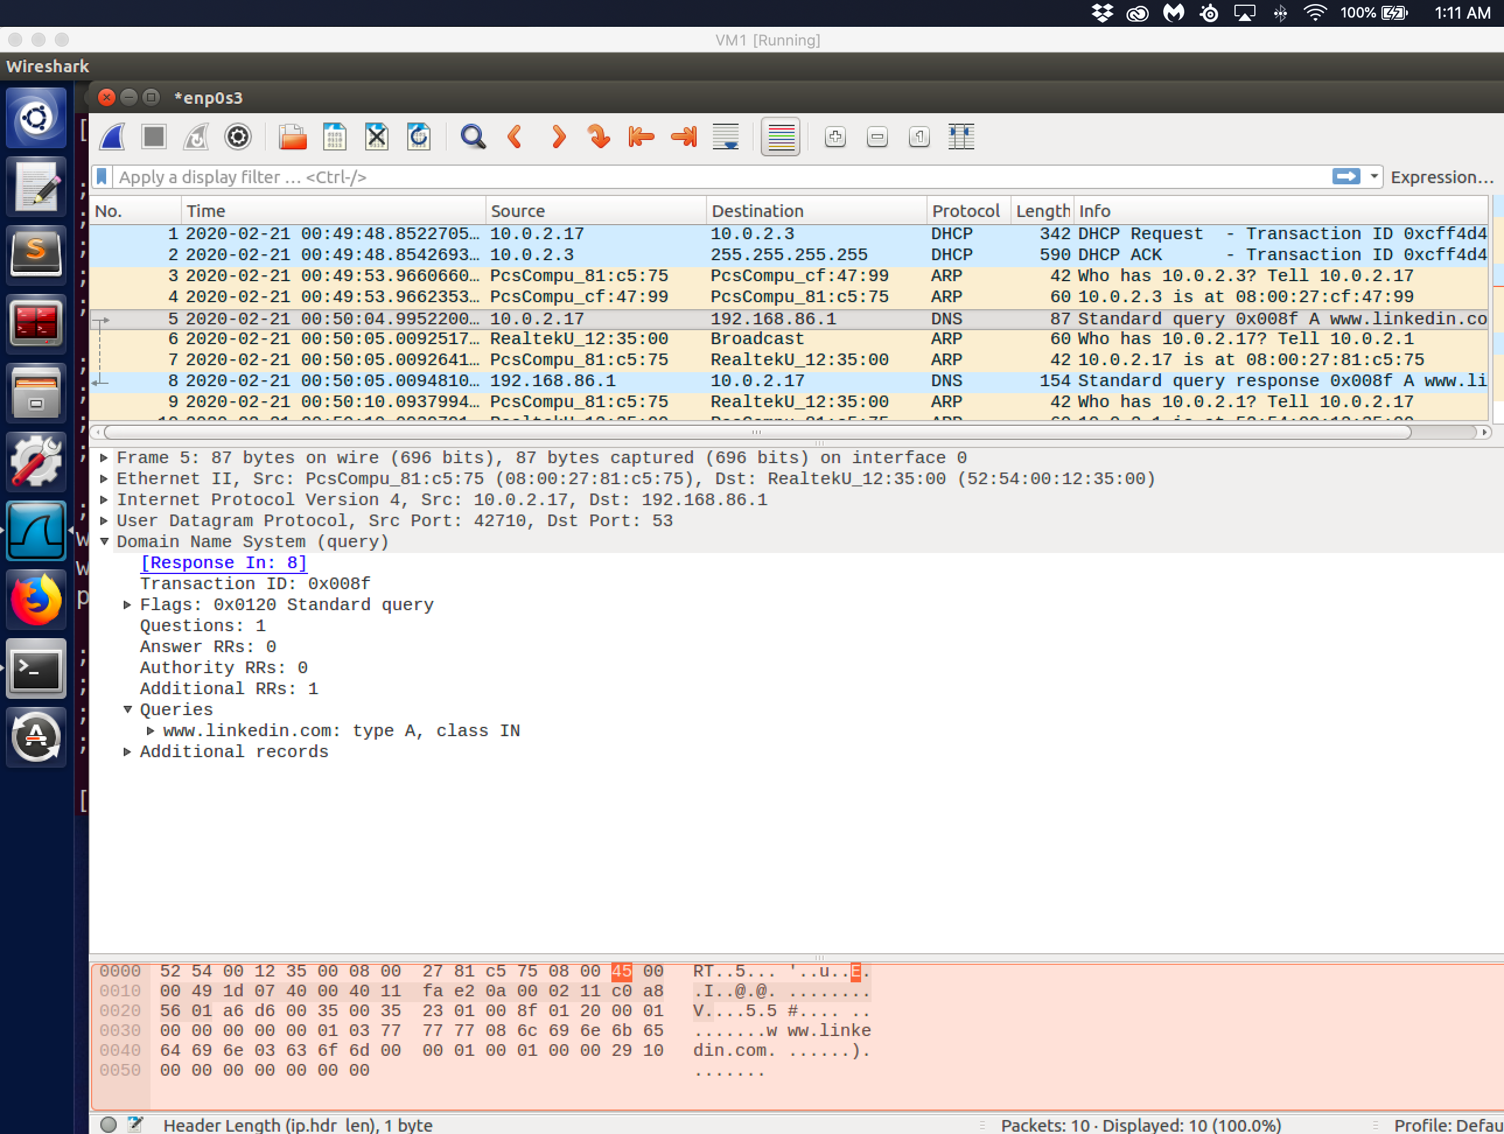

Observation: Performed a dig command on the site [www.linkedin.com](http://www.linkedin.com) on the VM 10.0.2.17. The screenshot showed the wireshark capture. The initial query shows that 10.0.2.17

Task 2:Set up a Local DNS Server

I chose www.linkedin.com to demonstrate and the following screenshot is showing the message traffic when

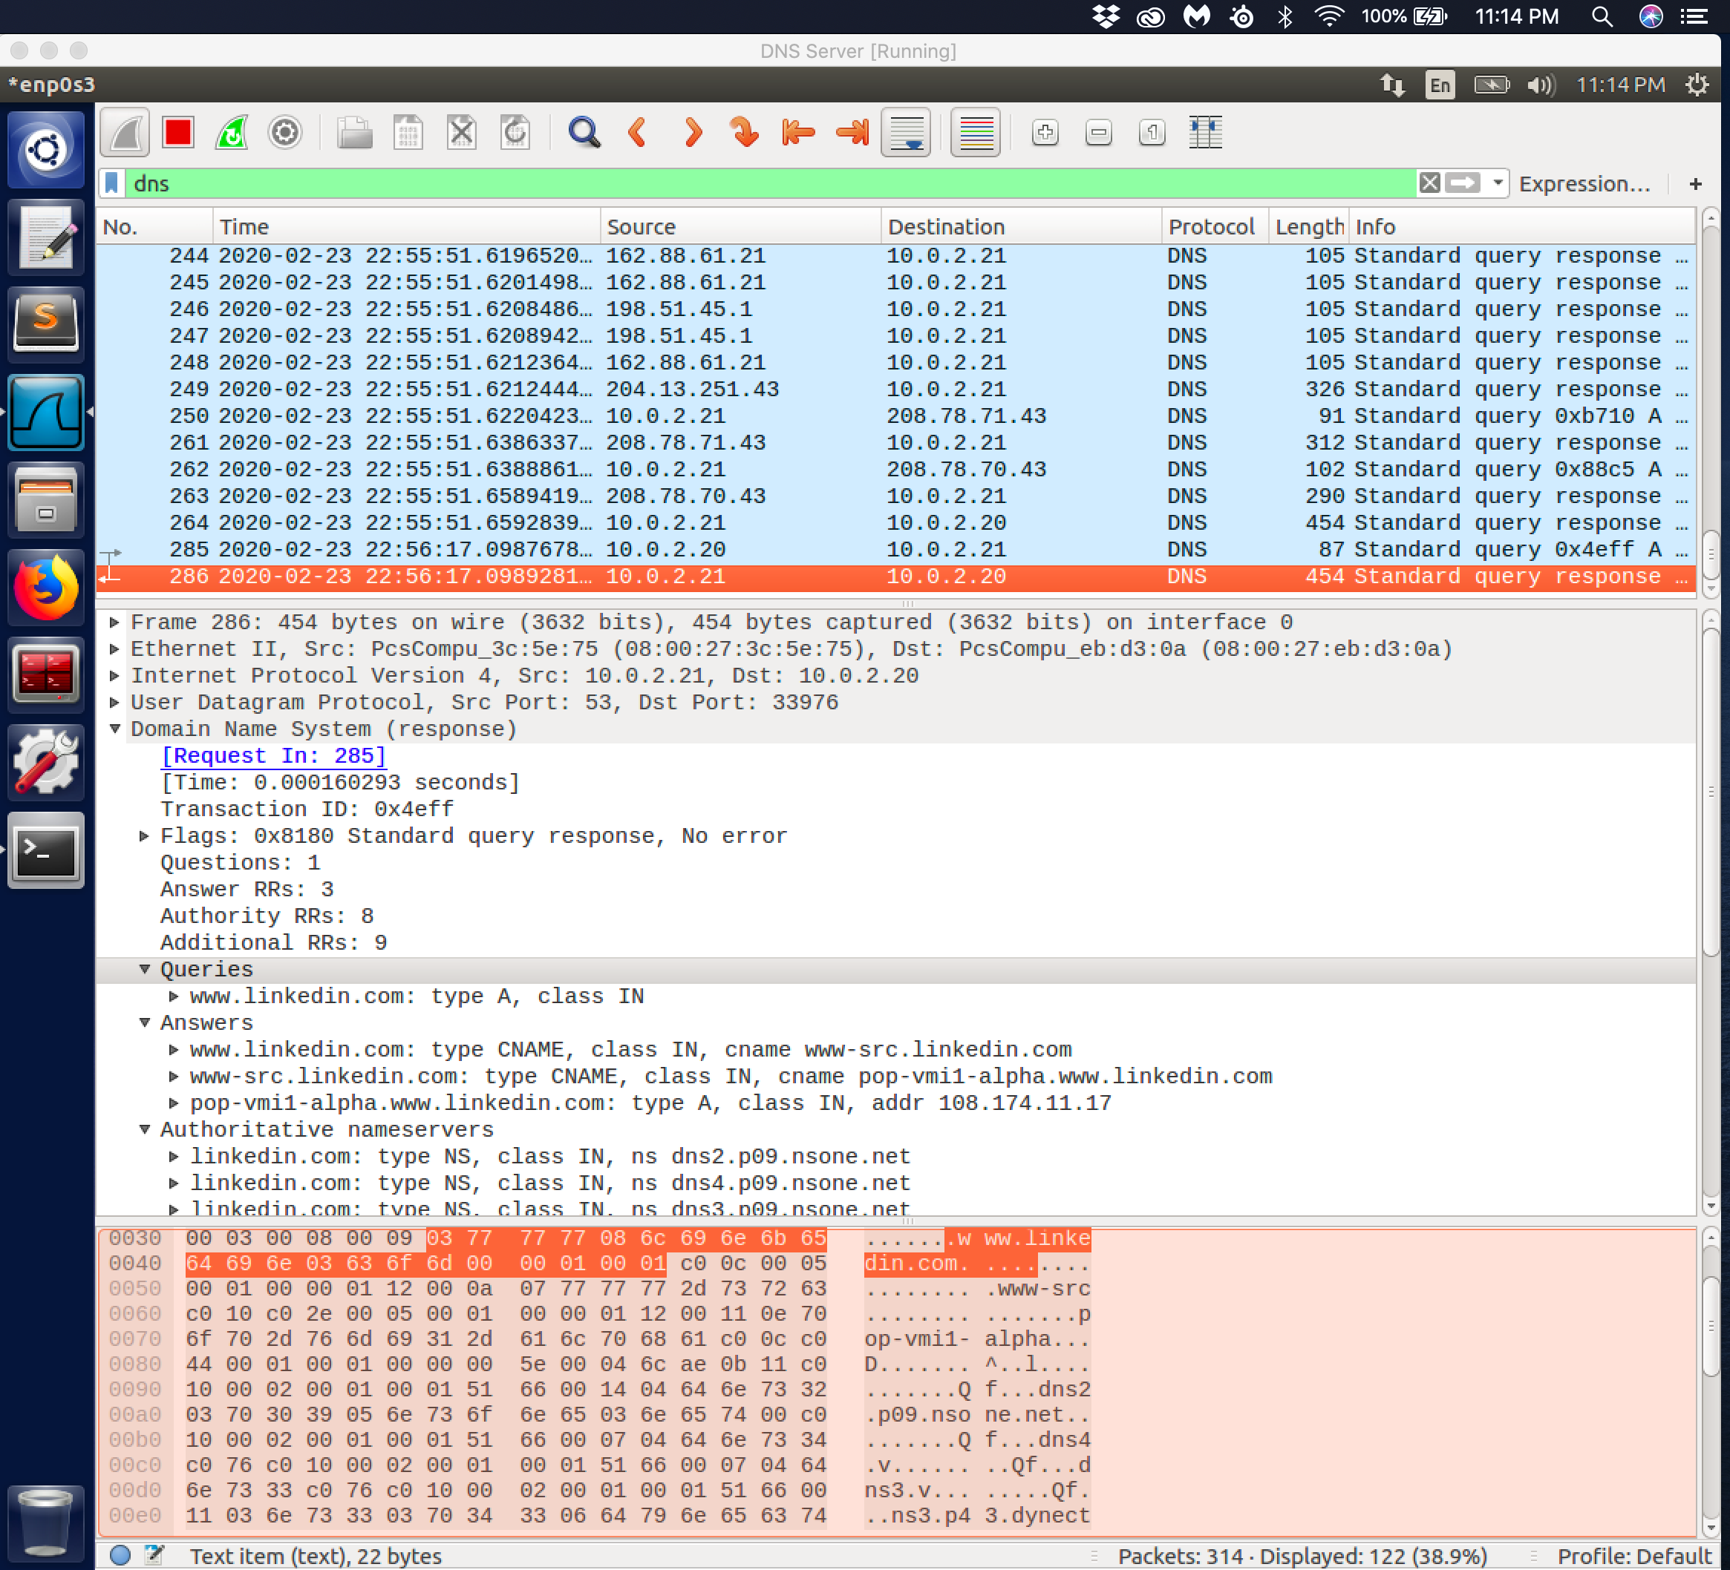

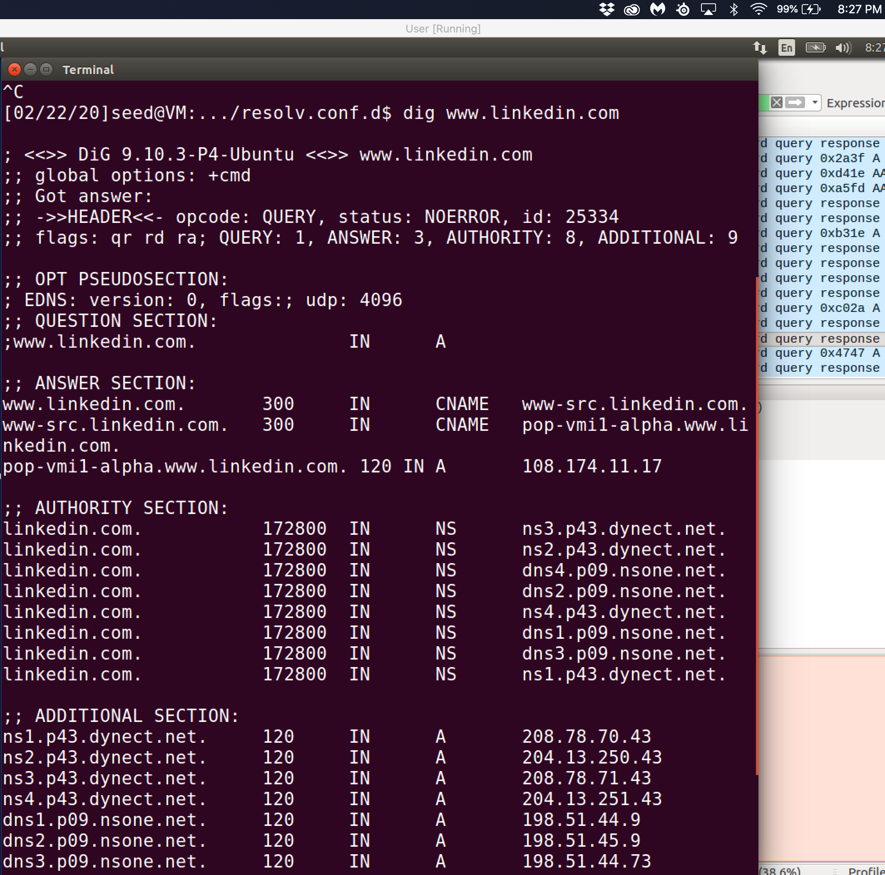

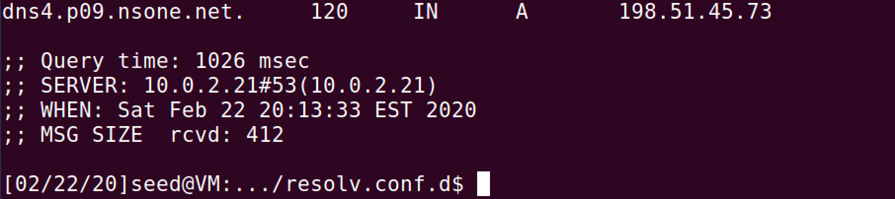

Observation: I have attached both the wireshark capture as well as the dig so that the additional section which shows the query process. The exchange is as follow the user queries the local dns Server 10.0.2.21, 10.0.2.21 queries 208.78.70.43, 10.0.2.21 gets the answer and 10.0.2.21 gives the answer to 10.0.2.20. The final packet that I have been highlighted indicated that the correct ip address was cached and returned to the user VM 10.0.2.20 destination ip address.

Task 3: Host a Zone in Local DNS Server

Per the lab instructions I create two files in the /etc/bind directory, example.com.db and 192.168.0.db. To ensure that these updated files were saved. The I am required to restart the bind9 server through the sudo service bind9 restart command. Then I needed to flush the cache on the server through the sudo rndc flush command. Earlier I defined in the named.conf.options file where to dump files when request to dump the cache. This will clear it as well as give the user the ability to see the details in the cache.

Then I went to my user machine 10.0.2.20 to give the dig [www.example.com](http://www.example.com) command. The record returns the nameserver ip address that is in the ANSWER section with the ip address of 192.168.0.101. In addition in the SERVER: value at the bottom of the screen you can see that the dns server that I set up on ip address 10.0.2.21 is queried on port 53.

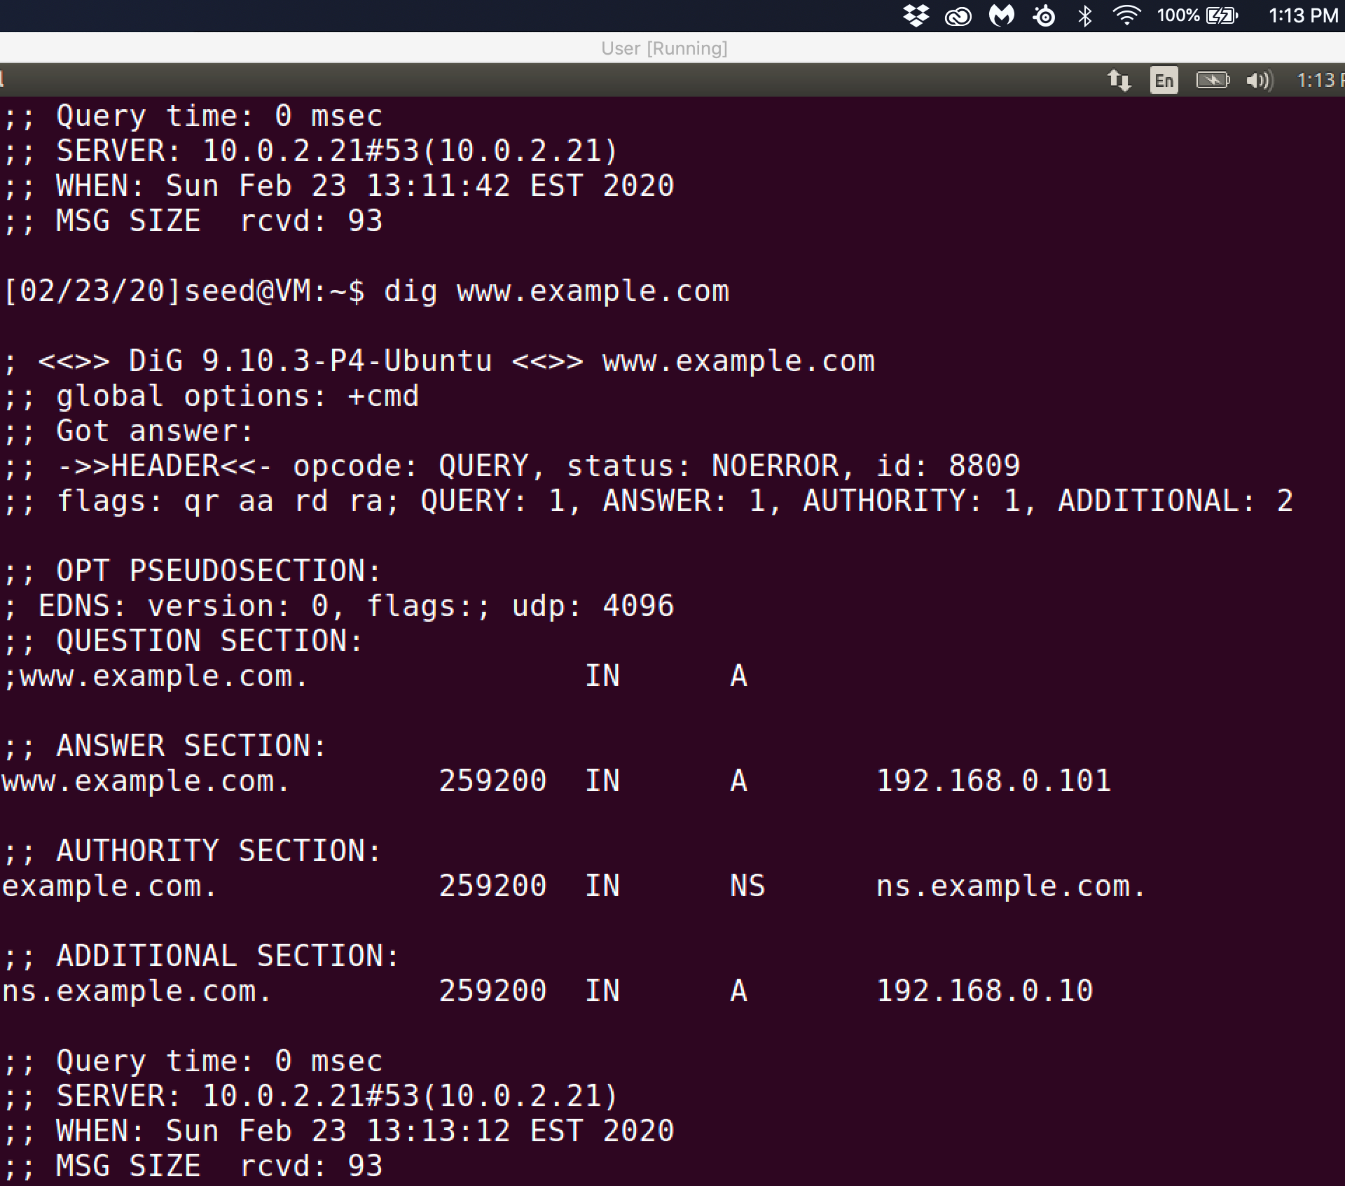

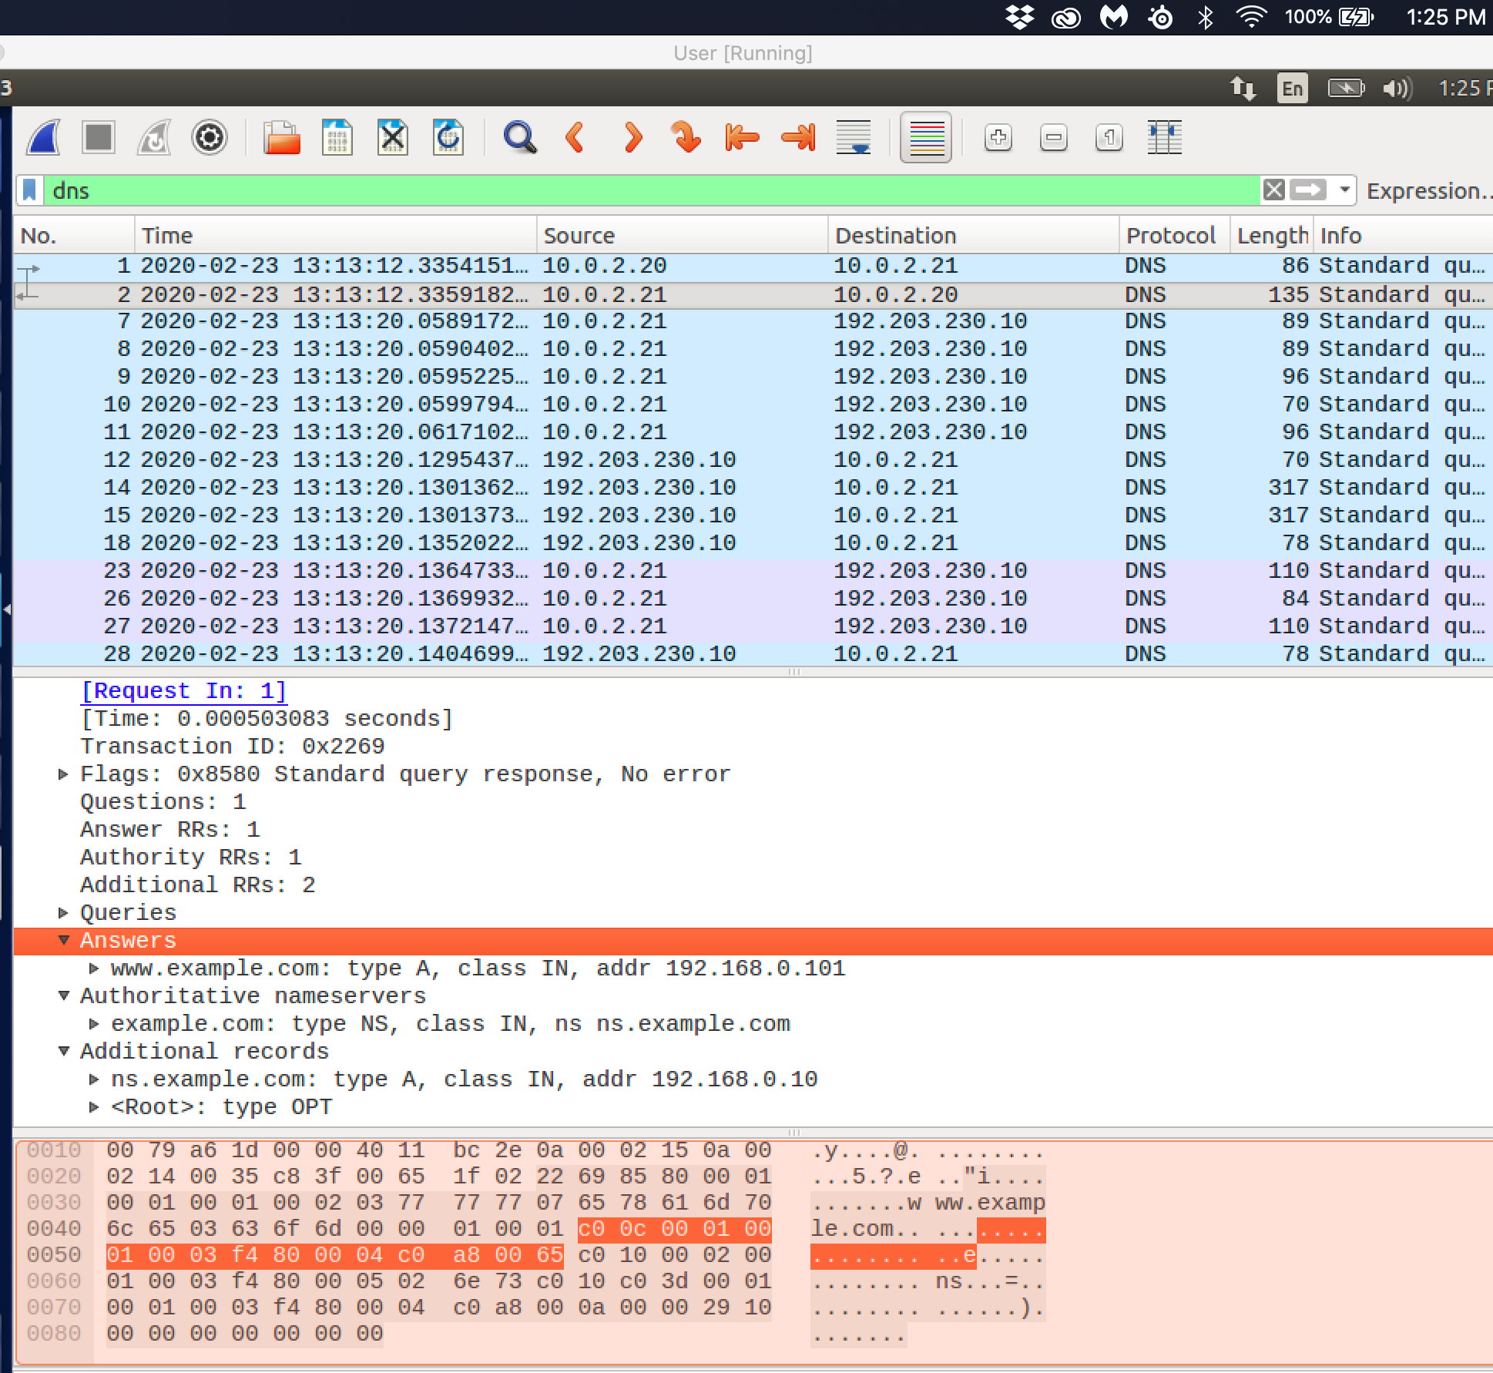

Observation: The wireshark capture shows that there only required dns packets sent to and from the dns server 10.0.2.21. The information in the packet show that the answer was stored in the dns server records.

Task 4:

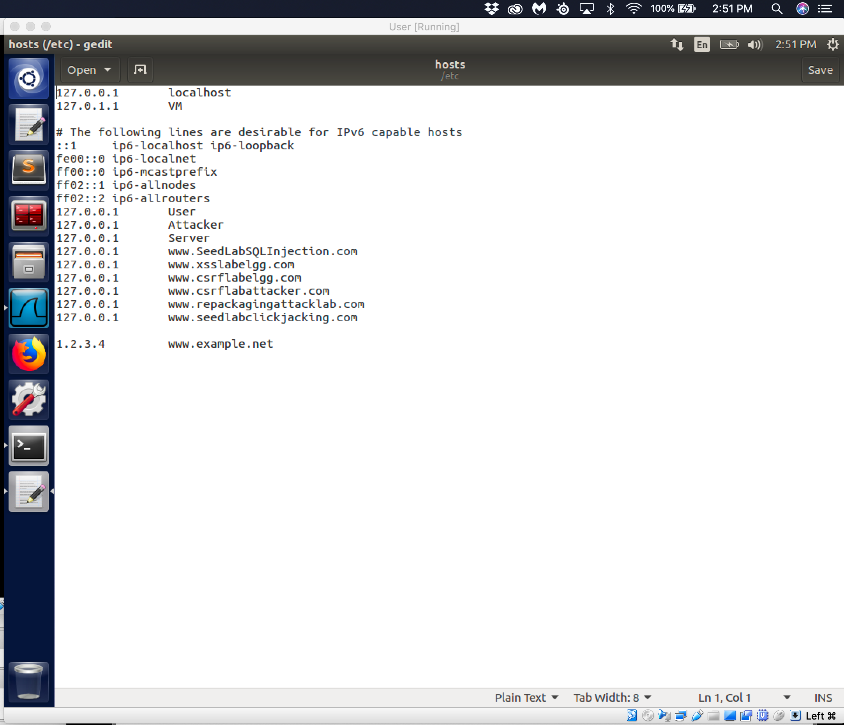

According to the lab instruction I add a new entry in the /etc/hosts file for [www.example.net](http://www.example.net) with an ip address of 1.2.3.4.

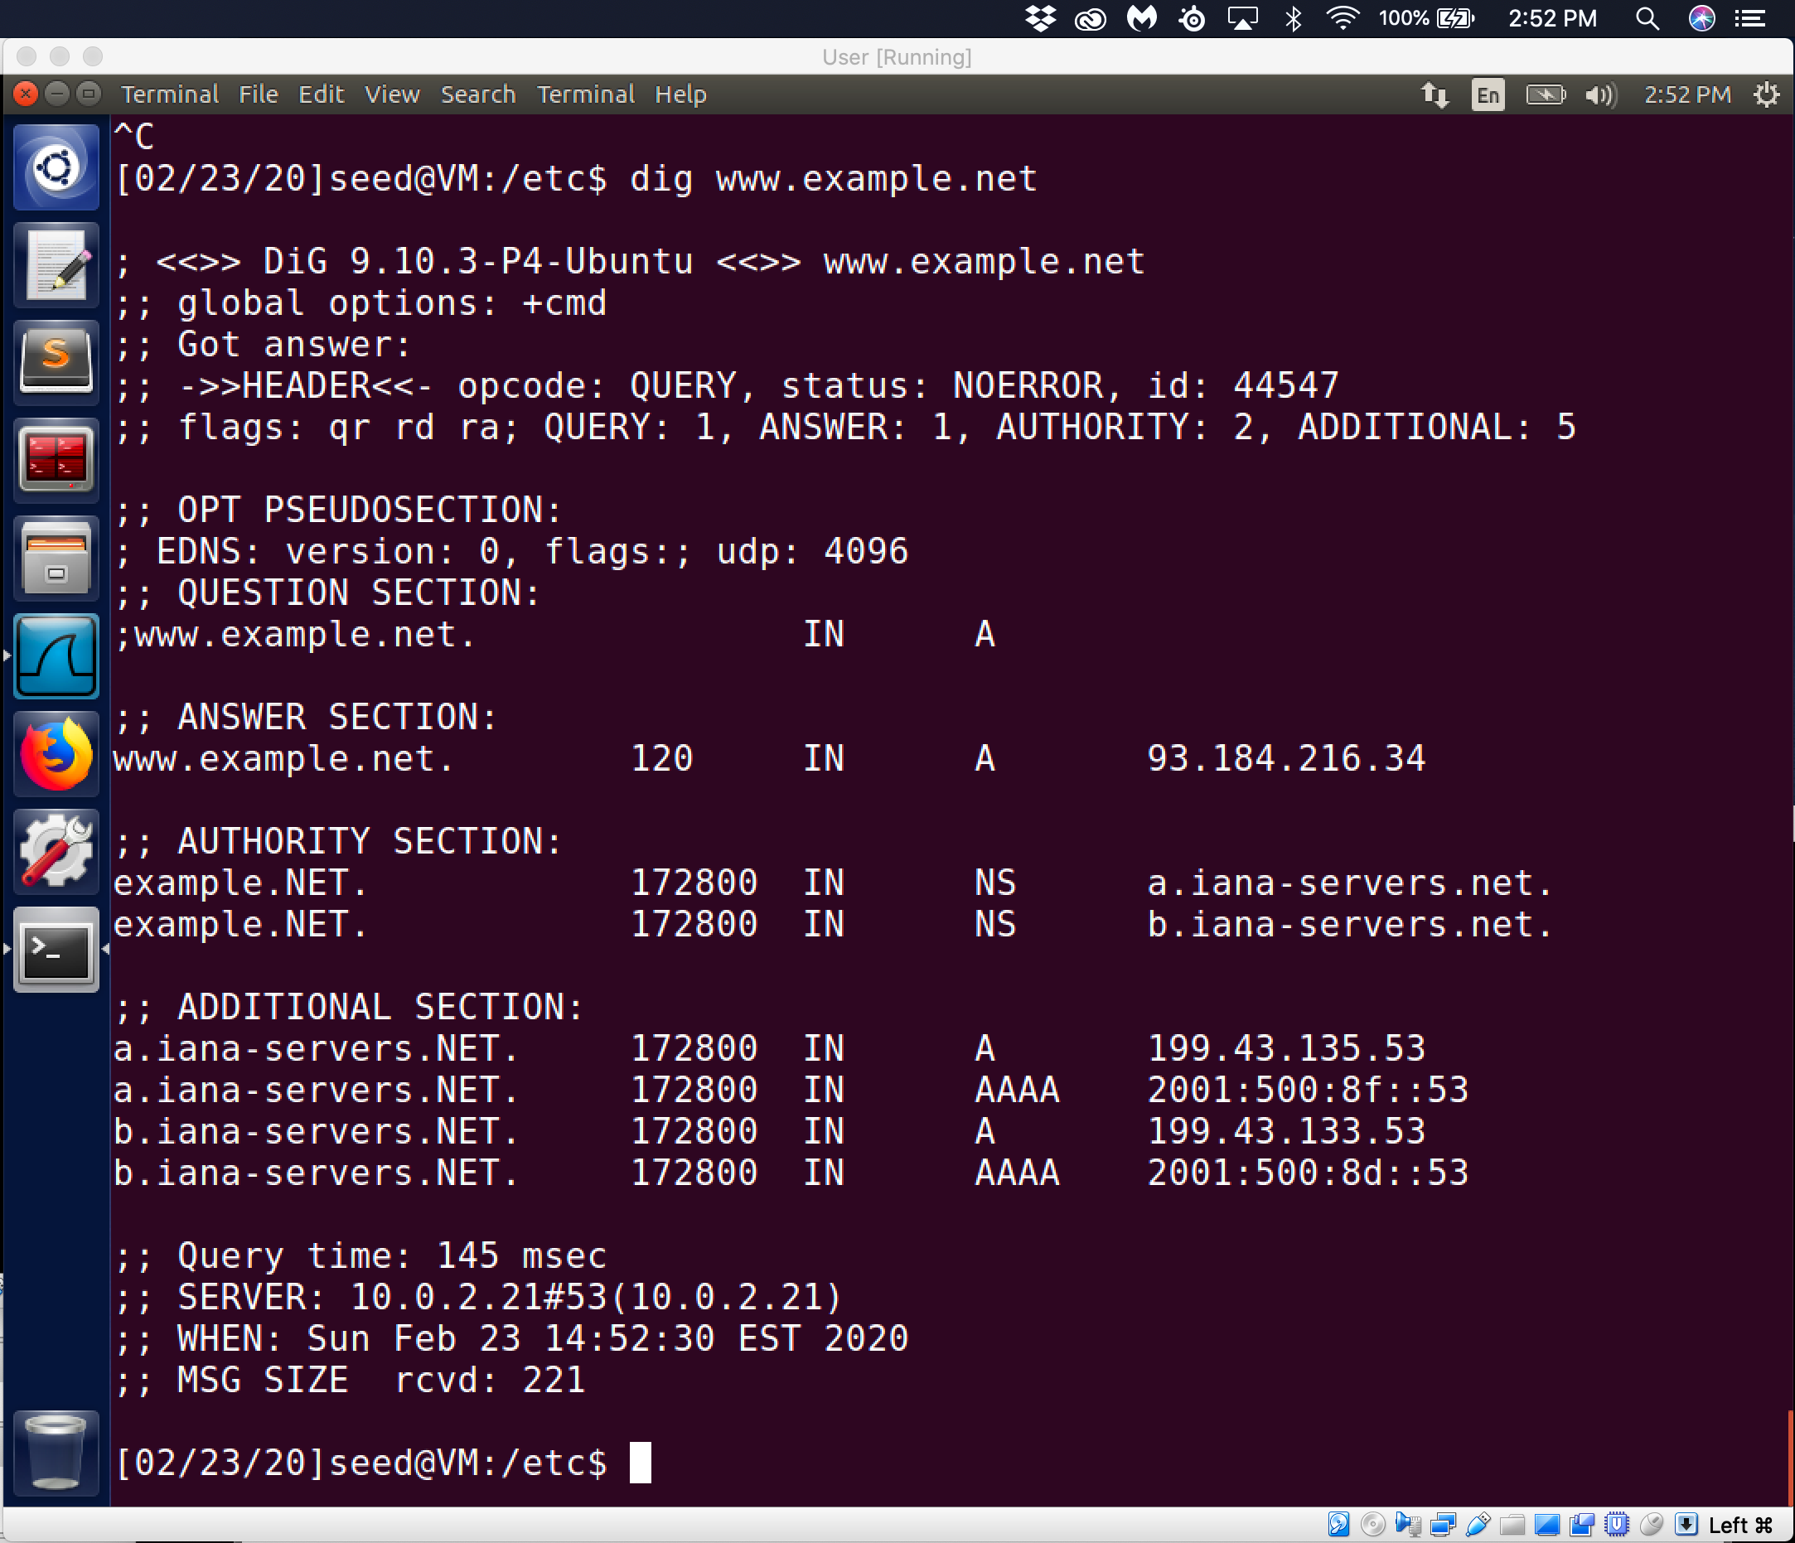

Observation: To illustrate how the hosts file works. I first do a dig command on [www.example.net](http://www.example.net) to see that in the answer section that a value other than what I added to the hosts file was in the answer section. Since the value is on the dns server and not on the user vm 10.0.2.20 it put out a dns query and got a reply from the example.net 93.184.216.34

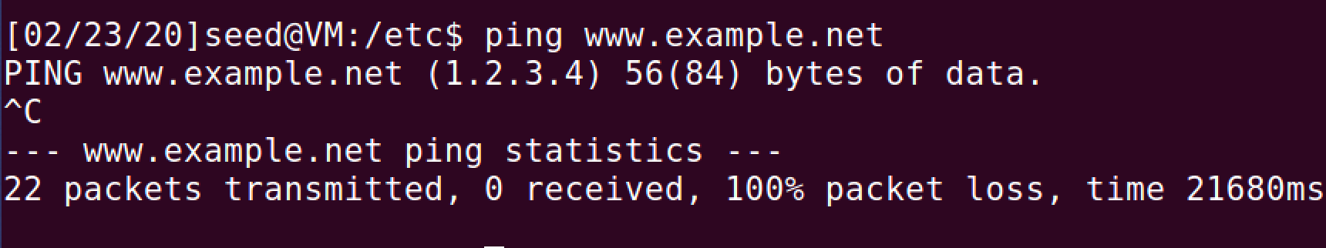

Observation: Through the use of the ping command to send out one or more icmp echo request to a specified destination ip address and waits for a reply. When I do this request the hosts file shows that instead of using the local DNS server that I set up on 10.0.2.21 but used the /etc/hosts file that had the added value for [www.example.net](http://www.example.net) with an ip address of 1.2.3.4.

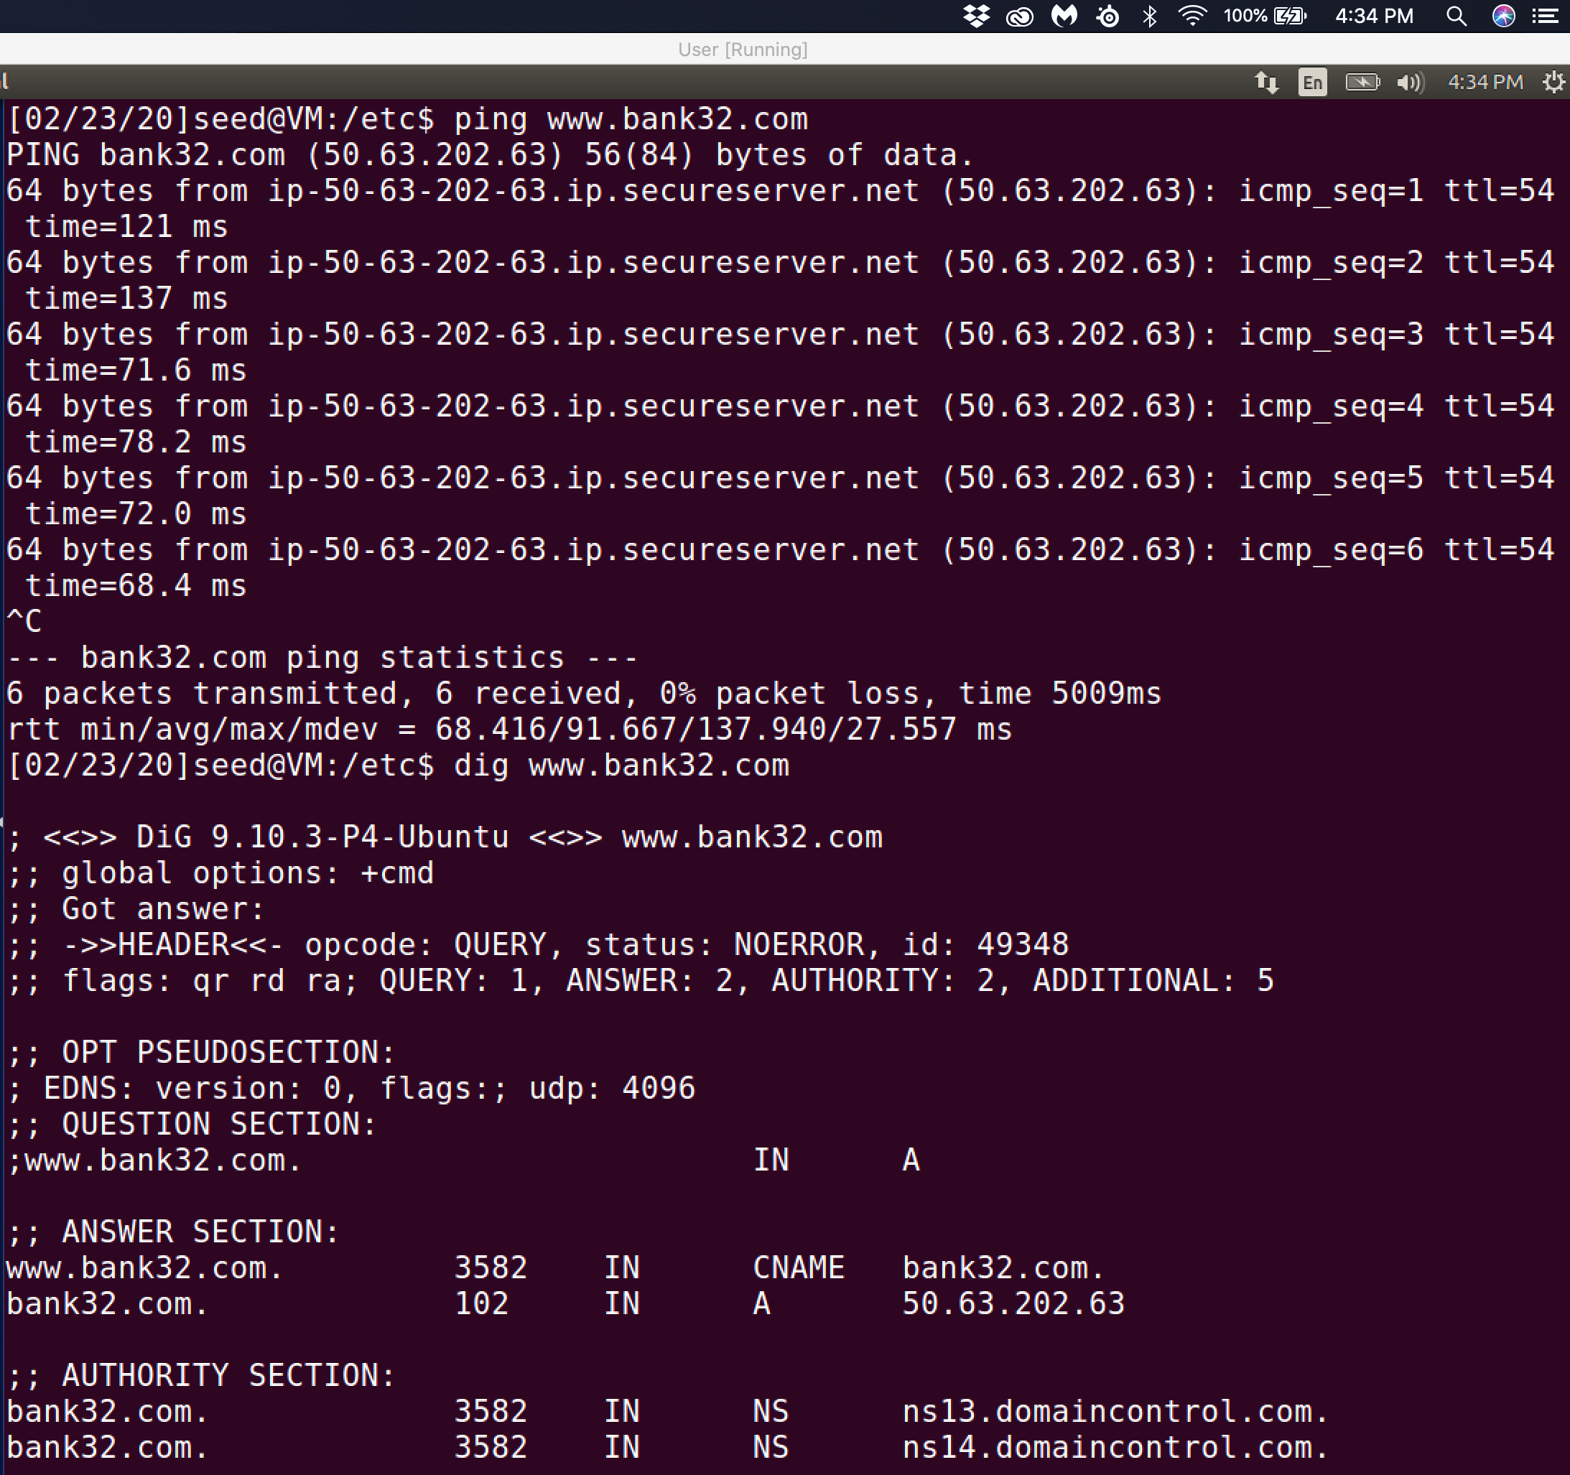

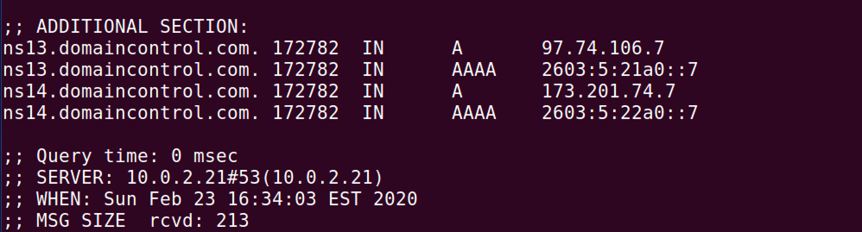

Observation: In order to ensure that the DNS lookups uses the local lookup instead of the remote looked I have first taken the above screen shot that uses remote lookup. To ensure that local lookup is used I modify the /etc/hosts/ file again to redirect [www.bank32.com](http://www.bank32.com) to 1.2.3.4.

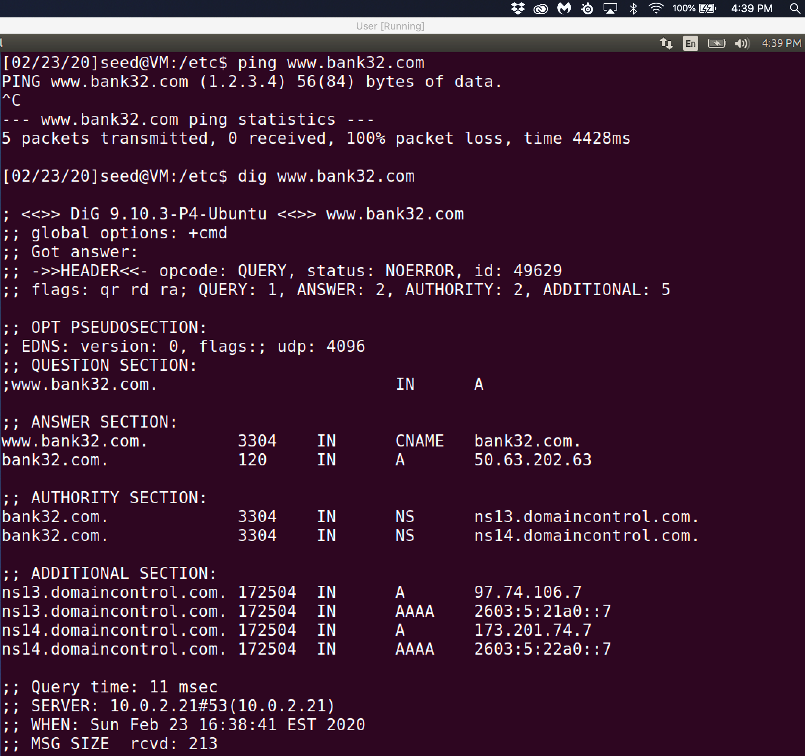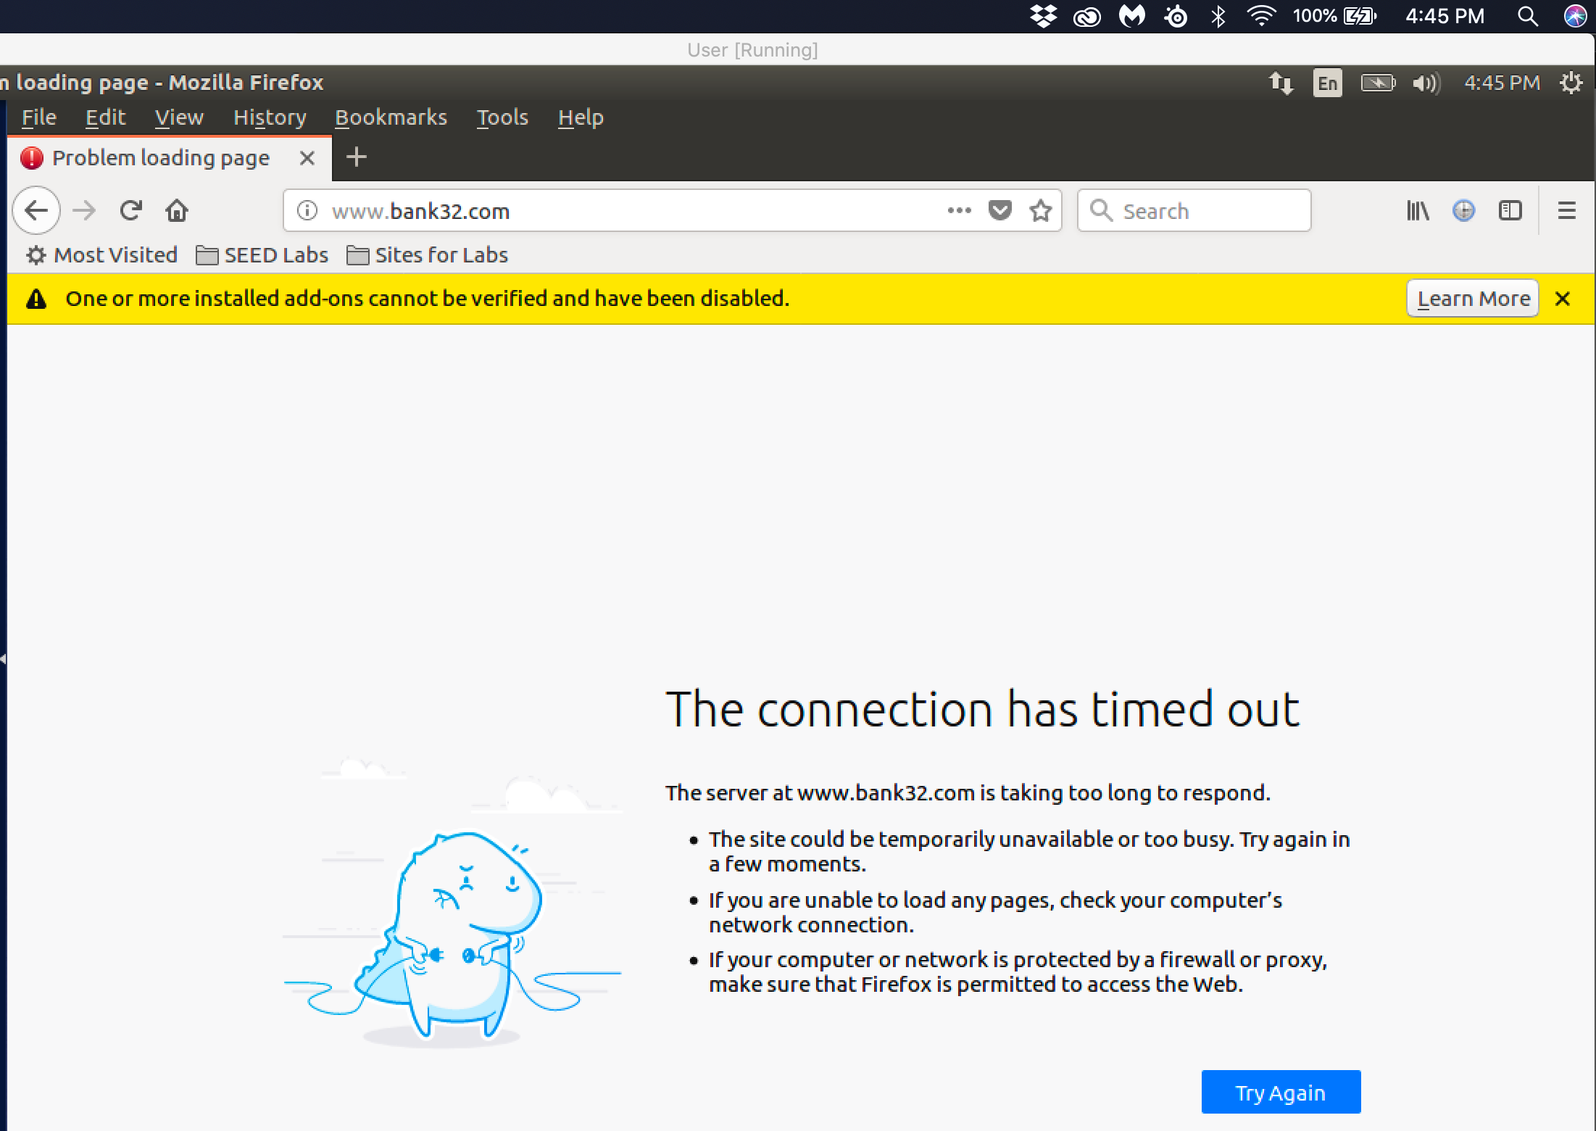

Observation: The results of the dig returnss the same results as the previous dig without the update to the /etc/hosts/ file. Ping uses the redirected ip address of 1.2.3.4. This also effects the ability for browsers to now access the [www.bank32.com](http://www.bank32.com) website. The connection to the [www.bank32.com](http://www.bank32.com) website will now result in a connection time-out.

Task 5:

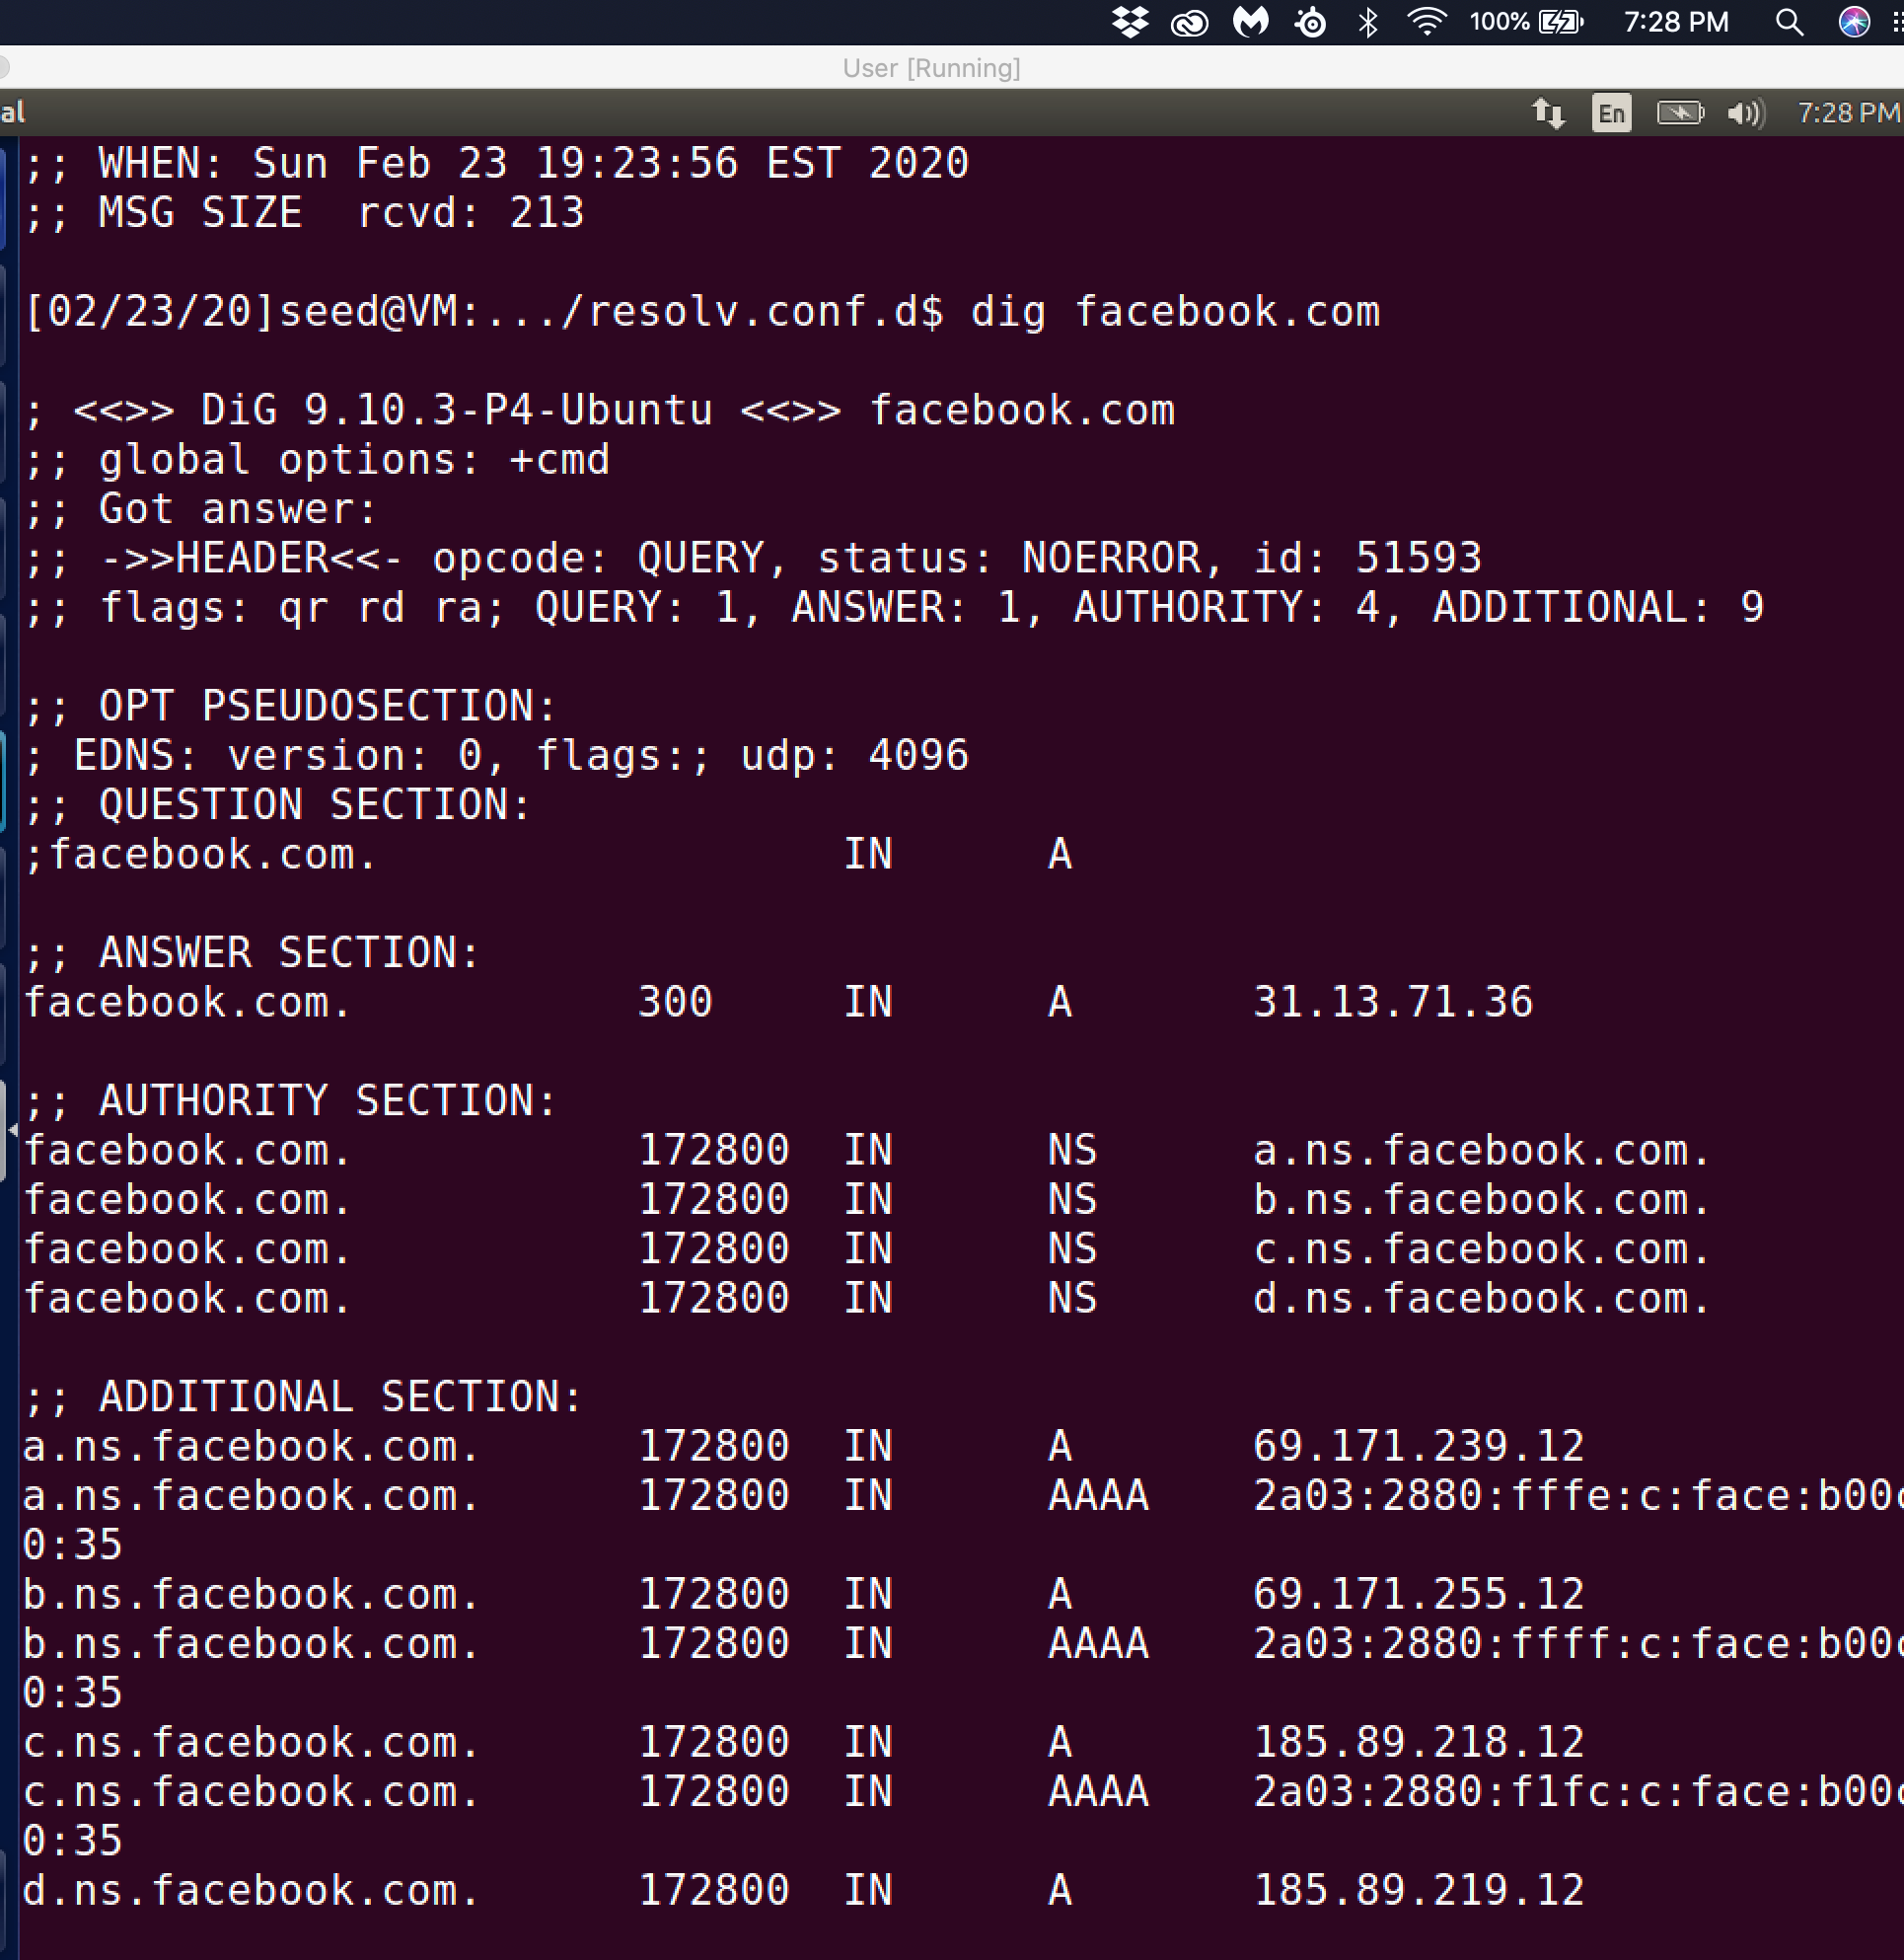

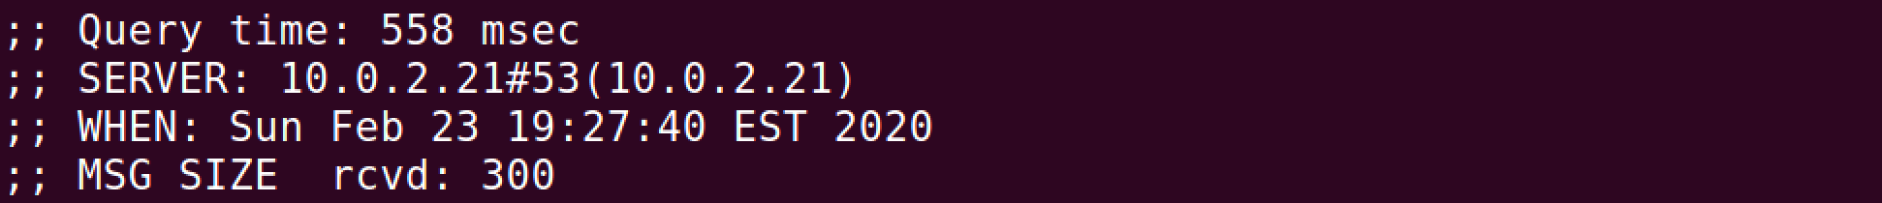

MY first step is the clear the dns cache in my local DNS nameserver 10.0.2.21 and this is the dig command and the response on the user machine 10.0.2.20.

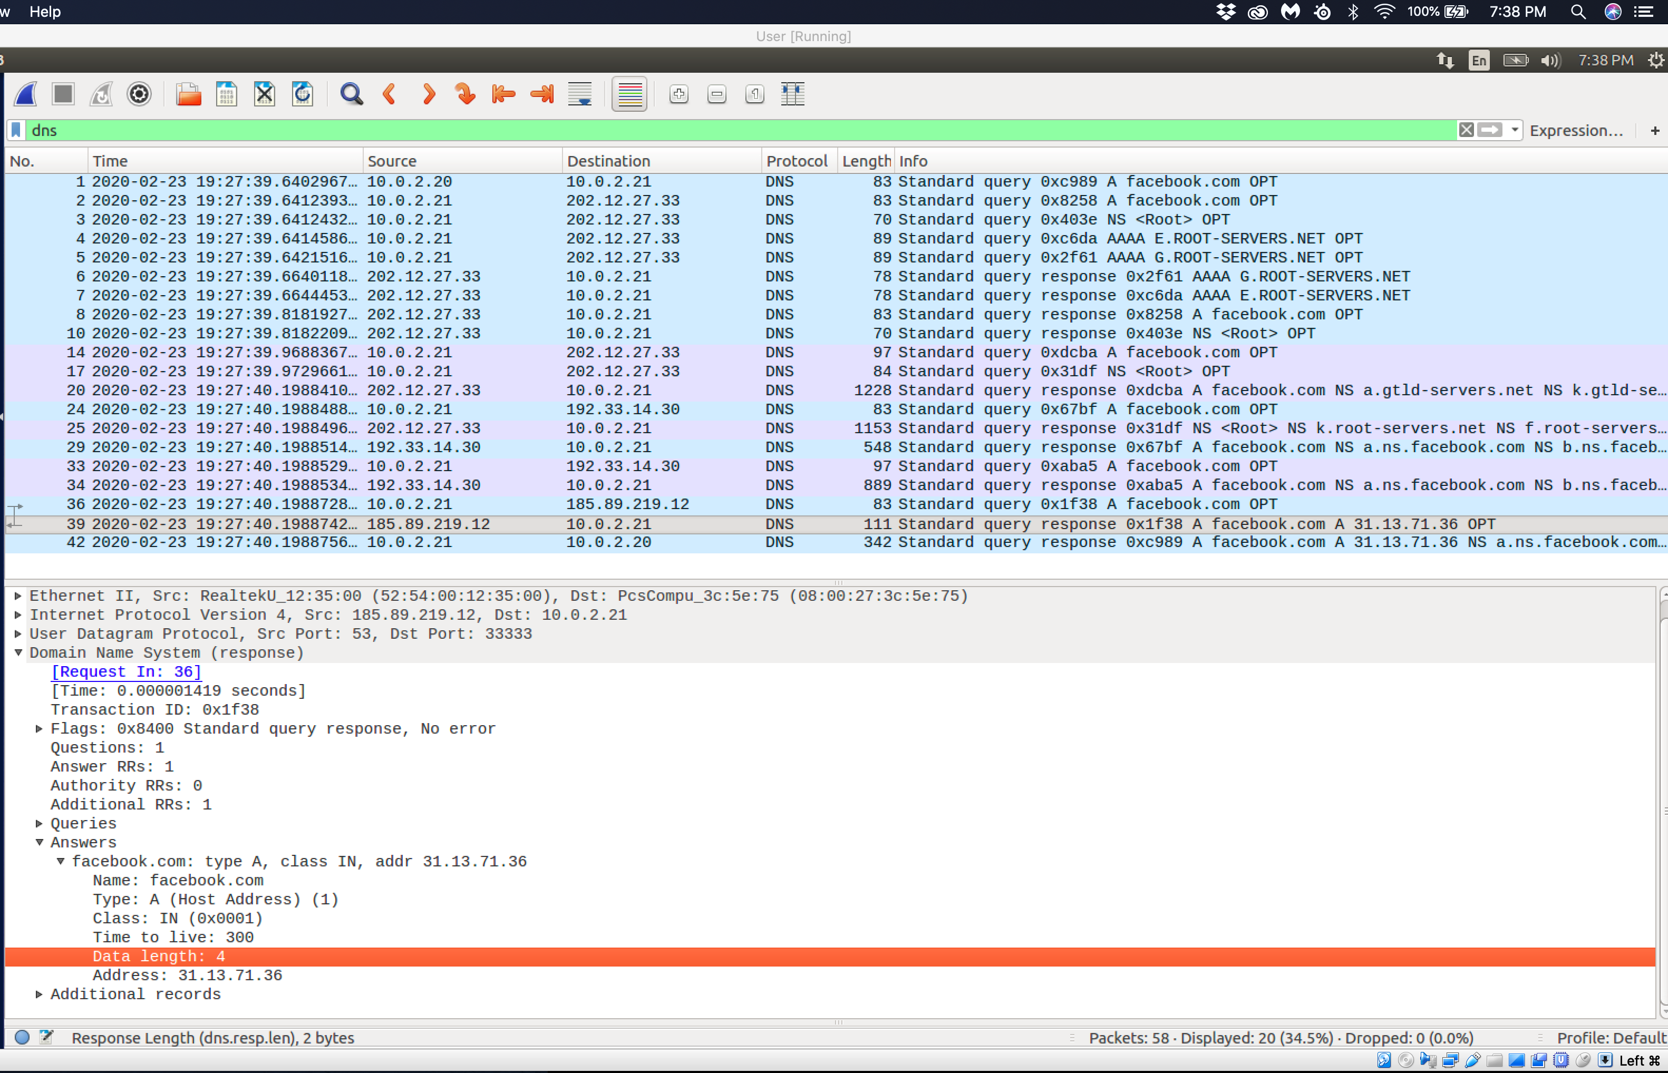

The user 10.0.2.20 queries the local name server 10.0.2.21. 10.0.2.21 queries the root servers(E.Root-Servers.Net OPT) on 202.12.27.33 as well as (G.Root.Servers.Net OPT ). Then 10.0.2.21 goes through the (a.gtld-servers.net) to 192.33.14.30(a.ns.facebook.com) until packet number 39 locates the server hosting [www.facebook.com](http://www.facebook.com) 31.13.71.36.

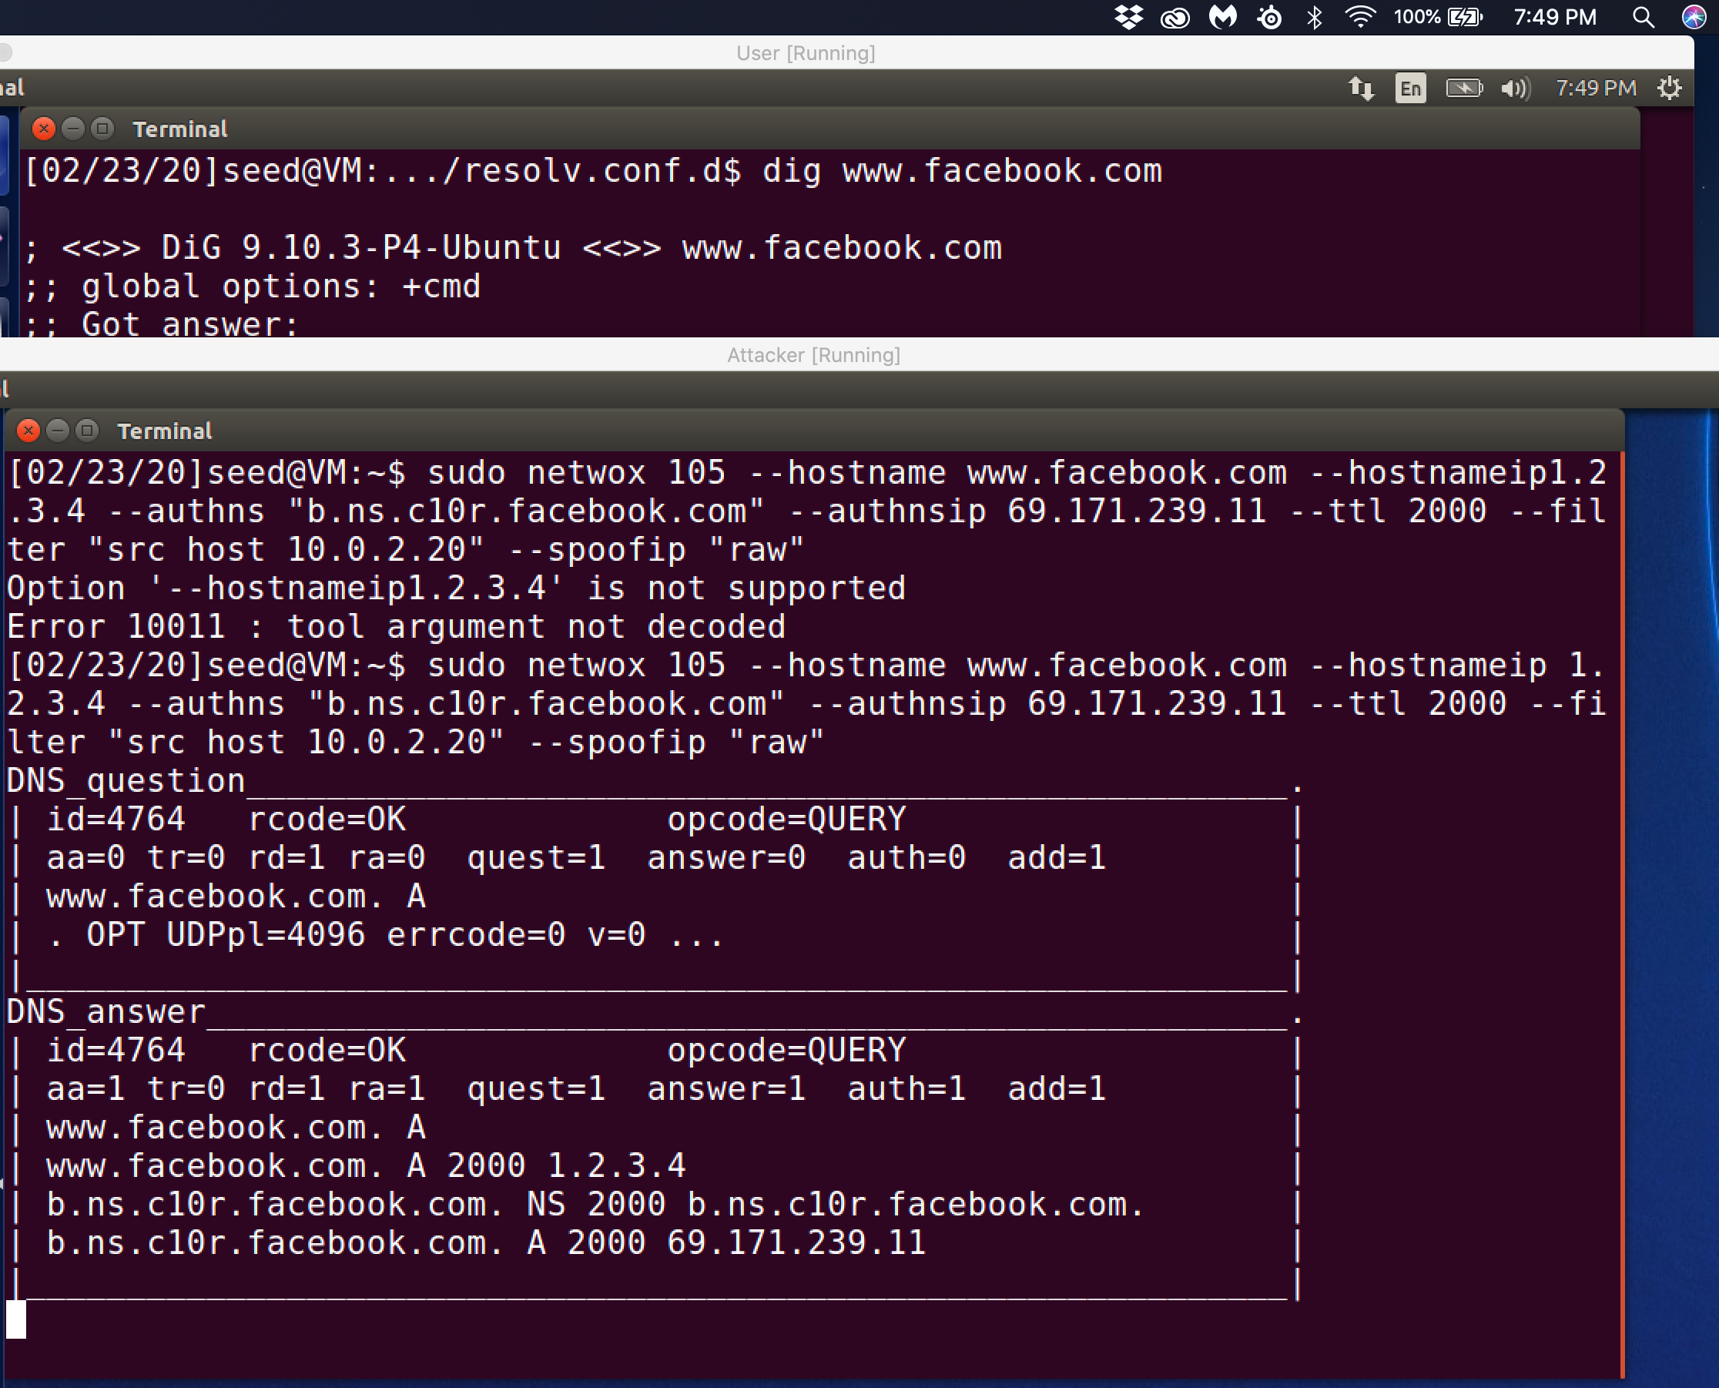

Observation: The netwox 105 tool sniffed the DNS query and spoofed the DNS reply. The above screenshot shows the result of the used of the netwox 105 tool. The authentic DNS query is returned to the local nameserver 10.0.2.21 and the cache is updated in the nameserver. The name server attempts to give this updated cache information to the user machine 10.0.2.21. This is rejected due to the fact that the machine 10.0.2.20 received the reply before the new reply arrives.

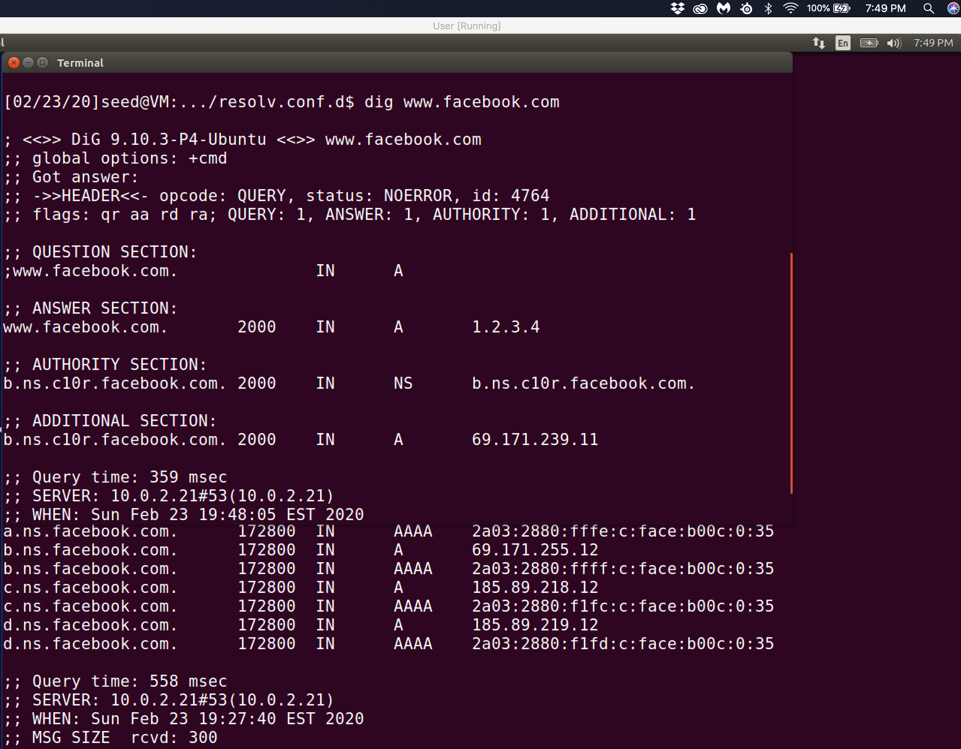

Observation: I flush the cache on the local dns nameserver and enter netwox 105 command on my attacker machine. I then dig to see if the I have been able to change the entry in the answer section to the value that I entered of 1.2.3.4.

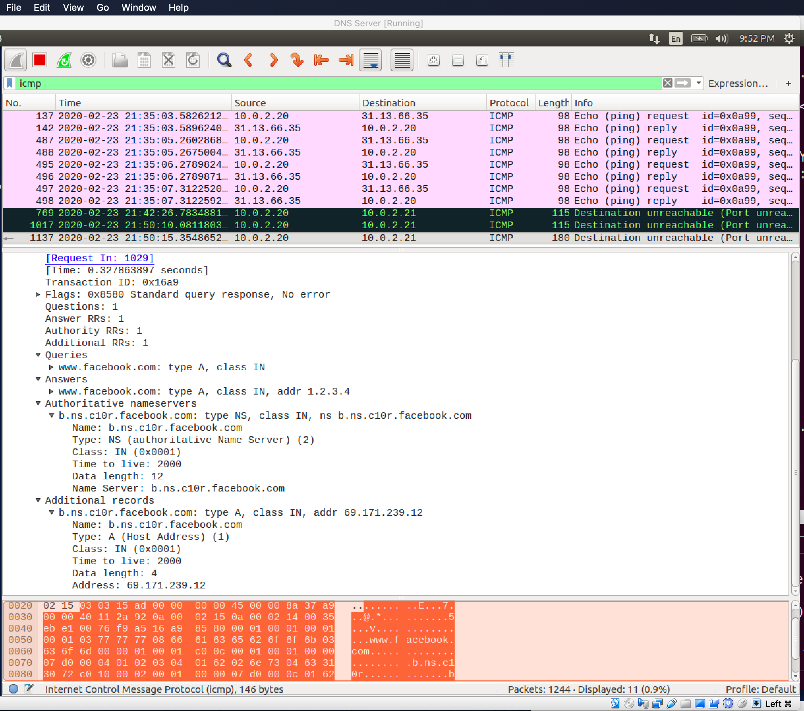

Observation: This wireshark capture shows what happens when the reply from the attacking machine is already received on the user machine. The attempt to send this information is show in the packets sent through the ICMP protocol results in a destination unreachable. The fact that the nameserver already received a response the result is that the user machine has closed therefore the communication from 10.0.2.20 the user vm and the local nameserver 10.0.2.21.

Explanation: This request an attack on a local DNS server called cache poisoning attack. The netwox 105 tools is listening for when the local DNS server sends out its iterative queries to get an answer from DNS servers located on the internet, when the netwox tool listens and captures that query and sends a spoofed reply to the local DNS server. The most important part of a DNS attack is the ability to forge DNS replies that used UDP transmission protocol. Attackers would need to know many details in the query. This can be captured by packets that are sent during a query. At times the attacker needs to clean the cache with the sudo rndc flush command. If I want to view if entries I an trying to inject in the local host then I would use the sudo rndc dumpdb –cache.





Observation: Even though the netwox command is active without the need to send off a query to the root-server then the local nameserver doesn’t need to do tha tbut can access this information in its cache then it quickly responds to any dns query with the failed message from the user account through the spoofed reply that is now loaded in the ANSWER SECTION: with a 1.2.3.4 ip address.

Task 6:

Observation: I need to use the netwox 105 tool to poison the cache while listening for user input in the user vm 10.0.2.20 that happens when the user types in dig [www.facebook.com](http://www.facebook.com).

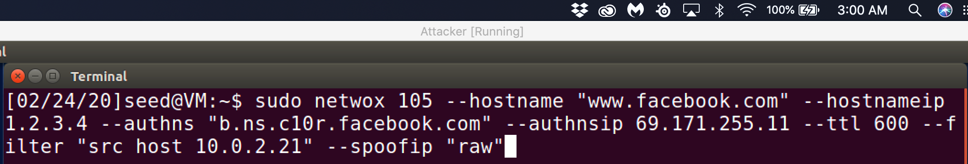

Observation: The screenshot below is what happens when hitting the dig [www.facebook.com](http://www.facebook.com) is entered into the terminal. This triggers the netwox 105 tool to send the spoofed reply.

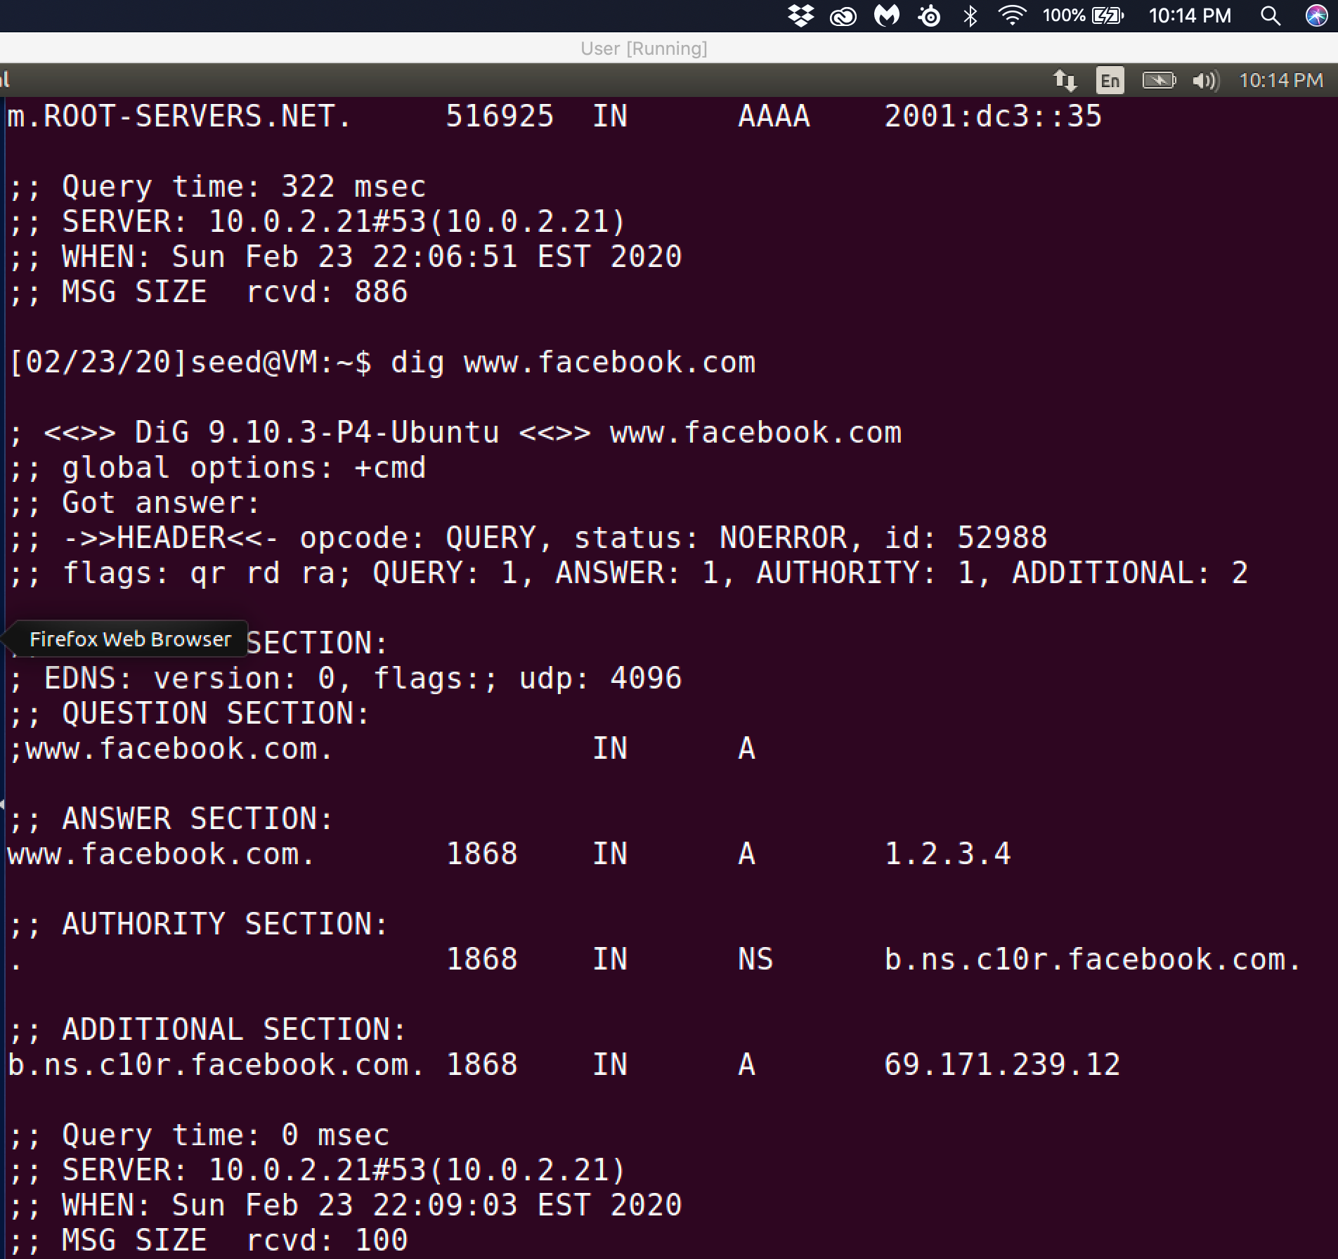

Observation: As soon as I get the spoofed reply has go back and forth between 10.0.2.21 the local nameserver to 10.0.2.20 the user vm. So now 1.2.3.4 is cached then whenever I dig [www.facebook.com](http://www.facebook.com) from now then I only see the two packets passed from the user vm to the nameserver and from the nameserver to the user vm.

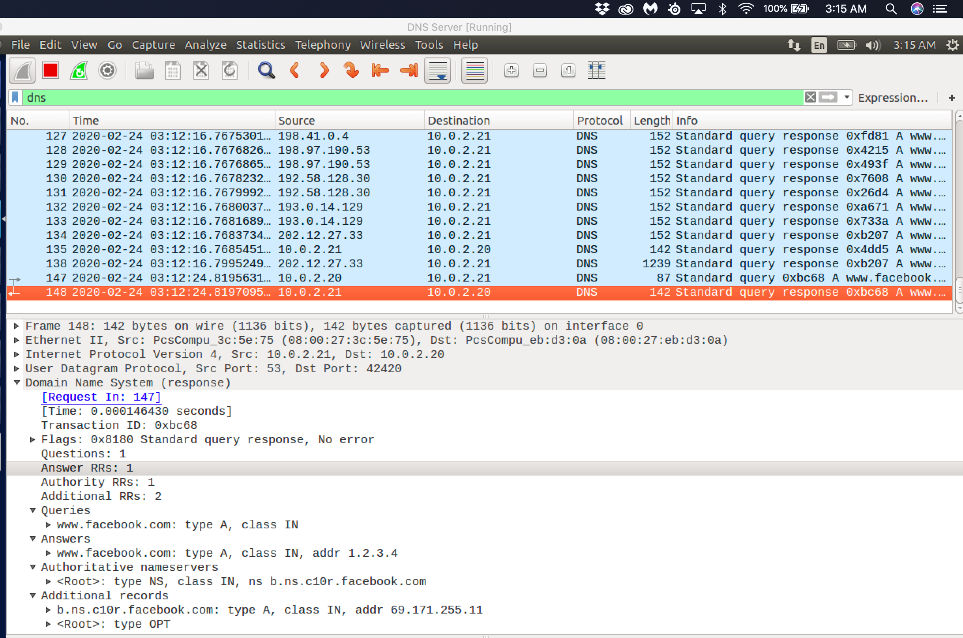

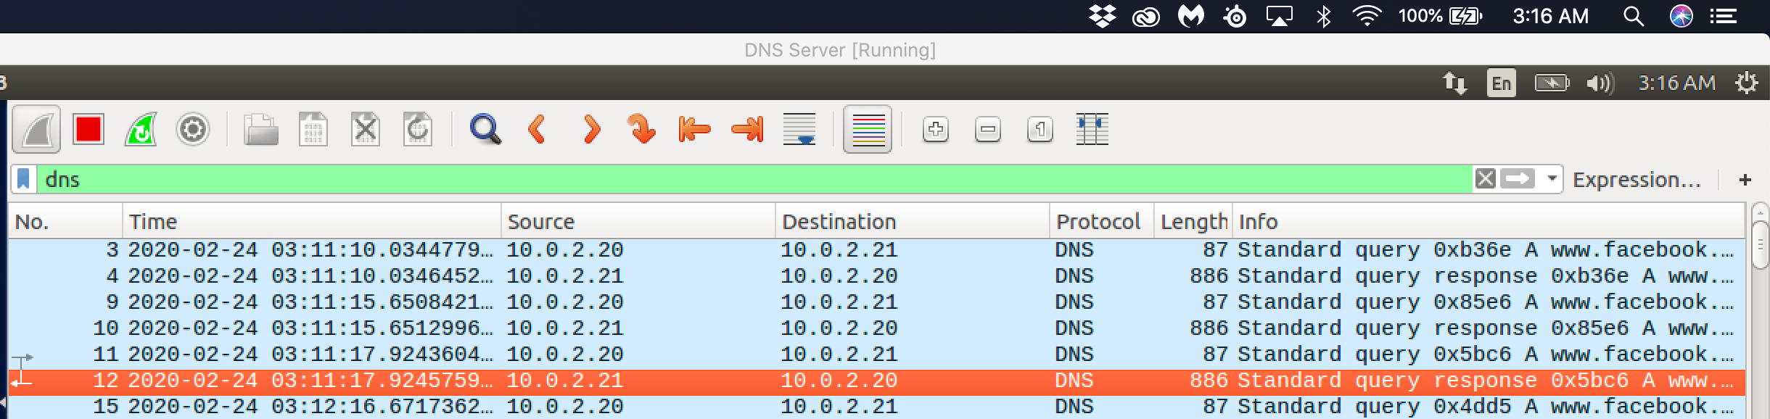

Observation: The above screenshot shows that once the spoofed reply is cached then it will first in order of precedence because DNS lookups look locally first.

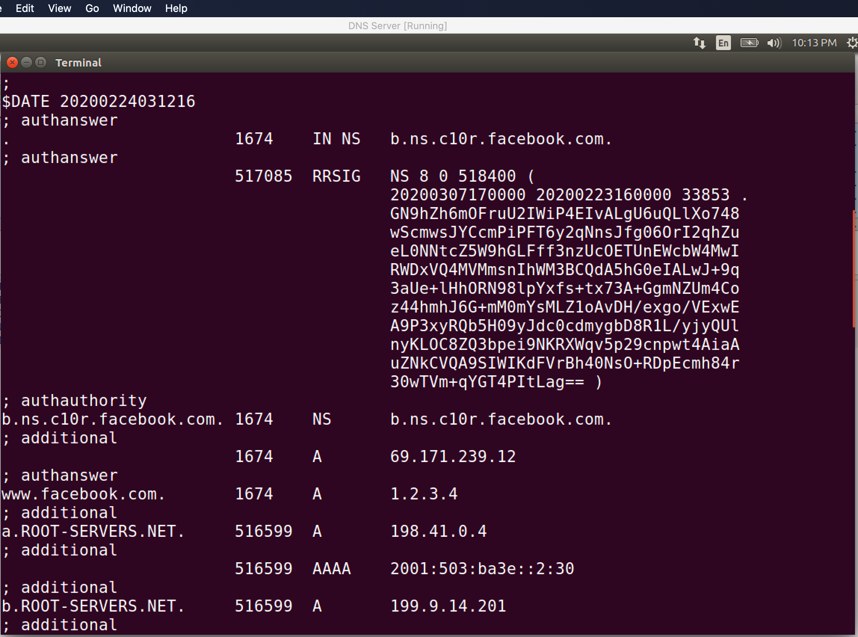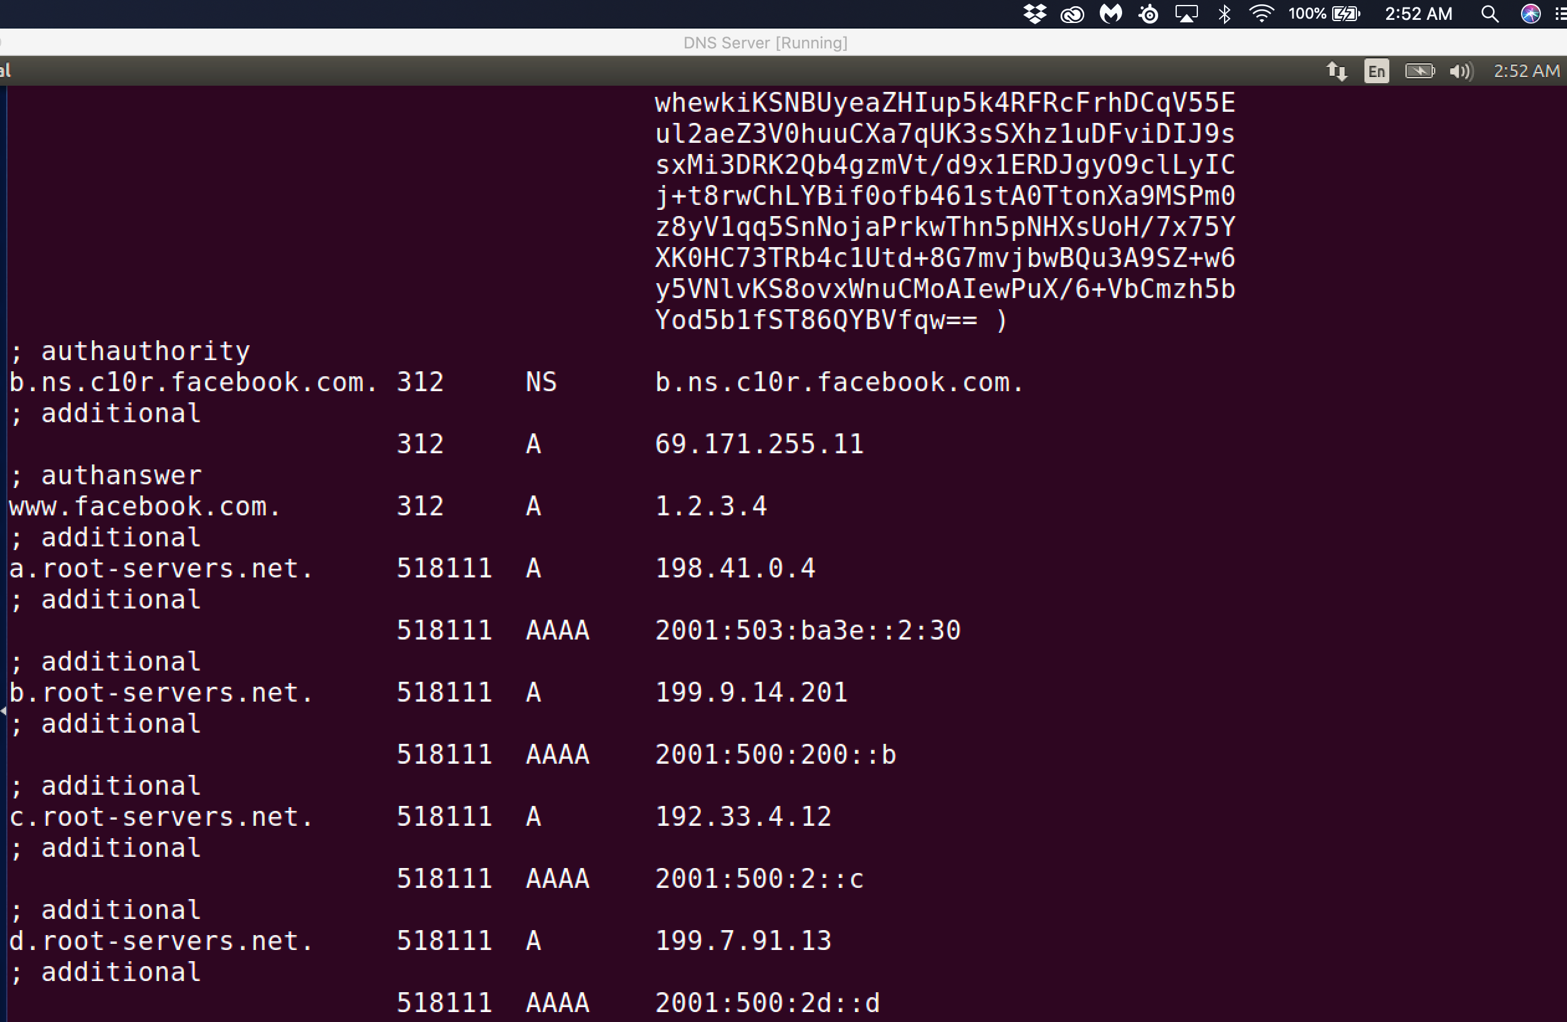

Observation: I also dumped the cache to the dump.db file and see that the spoofed ip address 1.2.3.4 is still cached so that whenever the there is a DNS query then the local hosts file will always revert to the spoofed ip address 1.2.3.4 when doing a DNS query because of the precedence for local lookup files than having the query recursively searching the nameservers on the internet.